[](https://www.duluthnewstribune.com/)

https://www.duluthnewstribune.com/news/local/draft-permits-would-require-keetac-meet-sulfate-standard-by-2030

[**News**](https://www.duluthnewstribune.com/news)[**Local**](https://www.duluthnewstribune.com/news/local)

**Draft permits would require Keetac meet sulfate standard by 2030**

State regulators also denied, again, a variance request from U.S. Steel that would have allowed it to discharge higher sulfate levels in a downstream lake.

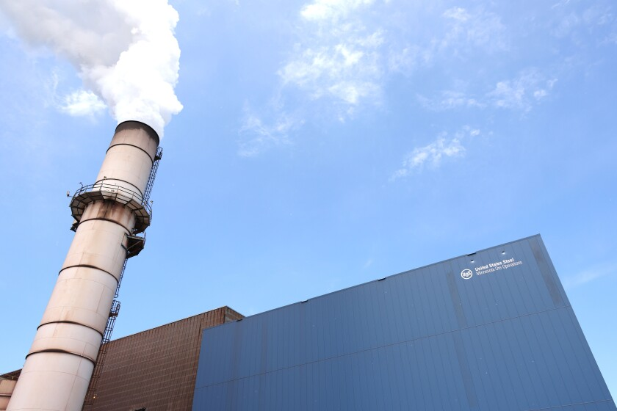

Steam rises from the Keetac DR-grade pellet plant in Keewatin on May 23, 2024.

Wyatt Buckner / File / Duluth Media Group

**[](https://www.duluthnewstribune.com/jimmy-lovrien)**

**By**[**Jimmy Lovrien**](https://www.duluthnewstribune.com/jimmy-lovrien)

July 17, 2025 at 5:45 PM

[Comments](https://www.duluthnewstribune.com/news/local/draft-permits-would-require-keetac-meet-sulfate-standard-by-2030" \l "conversations)

 Share

 News Reporting

KEEWATIN — Minnesota regulators, who again declined a request by an Iron Range taconite mine to allow higher sulfate levels in a downstream lake, have drafted two permits requiring the facility to meet the state sulfate standard for wild rice waters in five years.

The draft permits released by the Minnesota Pollution Control Agency earlier this month require water discharged from U.S. Steel’s Keetac iron ore mine and tailings basin to be treated so that it does not cause sulfate in downstream wild rice waters to exceed the state’s standard of 10 parts per million.

The company has until April 2030 to reach compliance.

The permits, which are open [for public comment until Sept. 8,](https://www.pca.state.mn.us/local-sites-and-projects/keewatin-us-steel-keetac) come just months after the [Minnesota Court of Appeals upheld](https://www.duluthnewstribune.com/news/local/minnesota-court-upholds-wild-rice-sulfate-limits-downstream-of-mine) the MPCA’s earlier denial of Keetac’s varience request. It is also more than a year after [the U.S. Environmental Protection Agency alleged Keetac](https://www.duluthnewstribune.com/news/local/epa-alleges-keetac-exceeded-sulfate-limit-nearly-300-times) released wastewater with sulfate levels higher than the permitted amount 299 times into nearby waters between September 2019 and September 2022.

Sulfate released into water from industrial processes such as mining and wastewater treatment can harm rice at elevated levels, as it converts into hydrogen sulfide within the sediment, but the mining industry [long argued the wild rice standard was too stringent.](https://www.duluthnewstribune.com/news/in-sulfate-debate-future-of-iron-range-mining-projects-hangs-in-balance)

U.S. Steel again requested a variance from the standard for wild rice waters downstream of its facility in May, but a preliminary decision by the MPCA denies the request, the state agency said.

[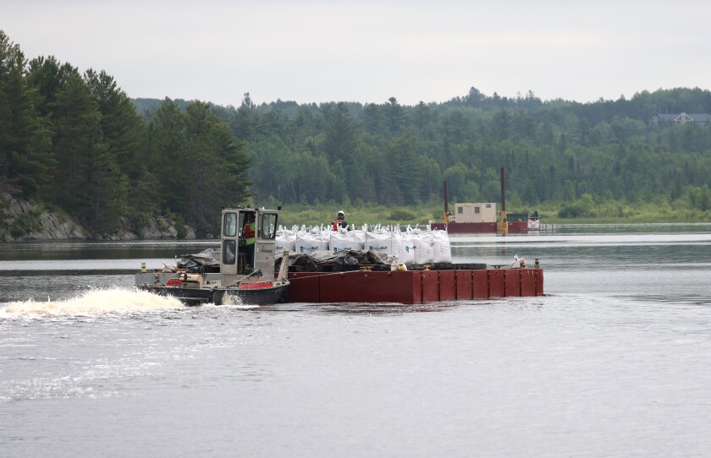](https://www.duluthnewstribune.com/news/local/worlds-largest-environmental-cleanup-of-its-kind-resumes-on-st-louis-river)

[**ALSO READ: World’s largest environmental cleanup of its kind resumes on St. Louis River**](https://www.duluthnewstribune.com/news/local/worlds-largest-environmental-cleanup-of-its-kind-resumes-on-st-louis-river)

Remediation of cancer-causing industrial toxins on the Thomson Reservoir resumes as environmental agencies aim to decontaminate the St. Louis River by the end of the decade.

Jul 11

Paula Maccabee, executive director and counsel for WaterLegacy, told the News Tribune that it was “a good thing” the variance was denied and that the MPCA did not jettison wild rice standards when drafting the permit.

Still, she wants to make sure there is a plan for enforcement.

“There needs to be action on the ground,” Maccabee said. “I like the paperwork, but paperwork is not going to reduce sulfate or restore fish habitat.”

Sulfate limits were put in Keetac’s 2011 permit, with compliance supposed to take effect by 2019.

But a [2015 state law](https://www.revisor.mn.gov/laws/2015/1/4/#:~:text=Sec.%20136.,January%2015%2C%202018.) sought to prevent the agency from adding impaired wild rice waters to the list and to prevent the state agency from enforcing sulfate reduction if it cost the permit holder money, effectively preventing the agency from enforcing the existing standard until it established new wild rice water-quality standards for sulfate.

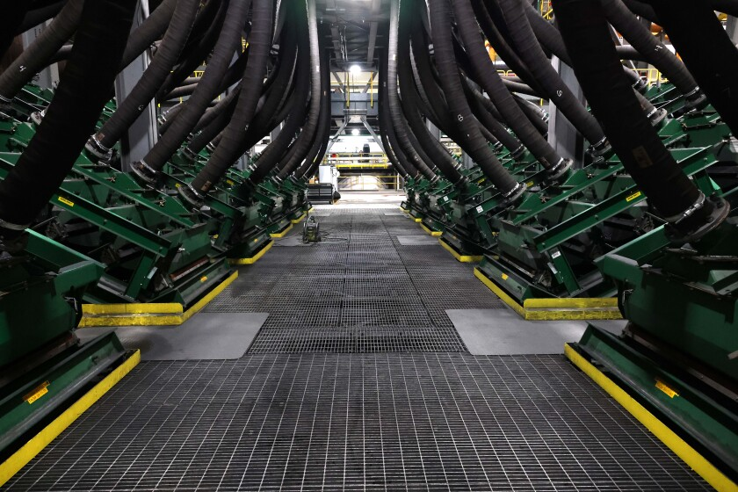

SA screen filters iron concentrate so large iron particles can undergo additional grinding at the Keetac DR-grade pellet plant May 23, 2024, in Keewatin.

Wyatt Buckner / File / Duluth Media Group

The MPCA tried to change that standard to a formula that would [include the water's organic carbon and iron content,](https://www.pca.state.mn.us/sites/default/files/wq-s6-43k.pdf) but withdrew its rule change proposal in 2018.

Additionally, [a 2016 state law](https://www.revisor.mn.gov/laws/2016/0/Session+Law/Chapter/165/) invalidated [the sulfate water quality-based effluent limits and compliance schedule for Keetac.](https://www.epa.gov/system/files/documents/2022-02/mn-sulfate-session-laws-final-ltr-021622.pdf)

[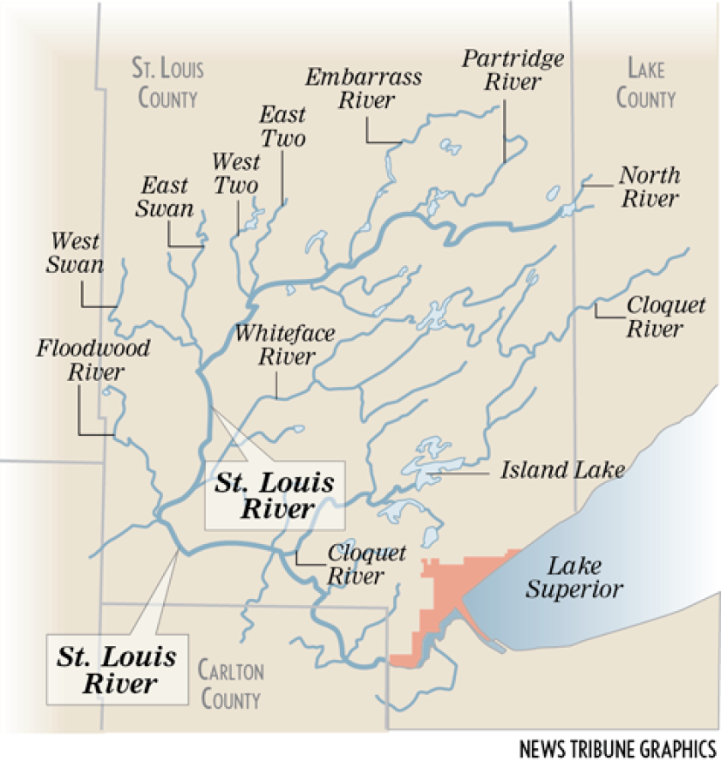](https://www.duluthnewstribune.com/news/in-sulfate-debate-future-of-iron-range-mining-projects-hangs-in-balance)

[**From 2011: In sulfate debate, future of Iron Range mining projects hangs in balance**](https://www.duluthnewstribune.com/news/in-sulfate-debate-future-of-iron-range-mining-projects-hangs-in-balance)

Len Anderson says you don't have to be a scientist to see what the big deal is with sulfate.

Apr 10, 2011

Then, in 2022, the [EPA wrote a letter to the MPCA](https://www.epa.gov/system/files/documents/2022-02/mn-sulfate-session-laws-final-ltr-021622.pdf) that said the laws "constitute an improper modification to MPCA’s authority to implement" discharge permits under the Clean Water Act.

The MPCA then began following the EPA’s rules, [noting the federal Clean Water Act trumped state law.](https://www.duluthnewstribune.com/news/local/minnesota-adds-20-wild-rice-lakes-and-streams-to-impaired-list#:~:text=%E2%80%9CSince%202020%2C%20that%20kind%20of%20overruled%20any%20state%20law%20because%20that%E2%80%99s%20a%20federal%20expectation%20and%20requirement%20from%20EPA%3A%20You%20follow%20the%20Clean%20Water%20Act%2C%E2%80%9D%20Leya%20Charles%2C%20the%20MPCA%E2%80%99s%20water%20assessment%20and%20impaired%20waters%20list%20coordinator%2C%20said%20in%20an%20interview%20with%20the%20News%20Tribune%20on%20Tuesday.)

Asked how this permit would be different from the 2011 permit and if it would be enforceable, the MPCA, in an emailed statement, referenced resolving the legal questions of the last decade.

“We began implementing the sulfate standard more than 15 years ago and have navigated a number of laws that conflicted with that standard,” the MPCA said Thursday. ”Ultimately, the EPA provided clear direction in its 2022 letter, which guided our development of this permit.”

It also cited a [2019 Supreme Court decision](https://www.supremecourt.gov/opinions/19pdf/18-260_jifl.pdf) that “changed how water permits are regulated under the Clean Water Act.”

The company previously told the Mesabi Tribune in [a July 14 story](https://www.mesabitribune.com/news/mpca-denies-u-s-steel-keetac-water-permit-variance-request/article_cb20500e-d7a3-4d9d-aa79-a618239971b0.html#:~:text=%E2%80%9CWe%20are%20disappointed%20with%20the%20MPCA%E2%80%99s%20preliminary%20decision%20to%20deny%20our%20request%20for%20a%20variance%20and%20are%20reviewing%20the%20decision%20to%20determine%20next%20steps%2C%E2%80%9D) that it was “disappointed” with the MPCA's denial of its variance request and that it was "reviewing the decision to determine next steps.”

But it did not go that far in its statement to the News Tribune on Thursday.

“We are currently reviewing the permit to better understand the potential implications at Keetac,” U.S. Steel said. “U.S. Steel is committed to Environmental Excellence, and to compliance with laws and regulations and are engaged in extensive research and development to meet our environmental obligations.

"We have been seeking innovative solutions to address sulfate requirements through partnerships with the University of Minnesota Natural Resource Research Institute and Innocentive, an open marketplace for crowdsourcing novel technology solutions.”

***This story was updated at 3:45 p.m. on July 19 to correct the following quote from Paula Maccabee: "I like the paperwork, but paperwork is not going to reduce sulfate or restore fish habitat.” The story was originally posted at 5:45 p.m. on July 17. The News Tribune regrets the error.***